Code Review: I2311066
Reviewer: James Wood
Date: December 8th, 2023

Bugs
- App Integration uses the back-end SO objects, so handling of the Global connection will still be required unless we update AppInt.
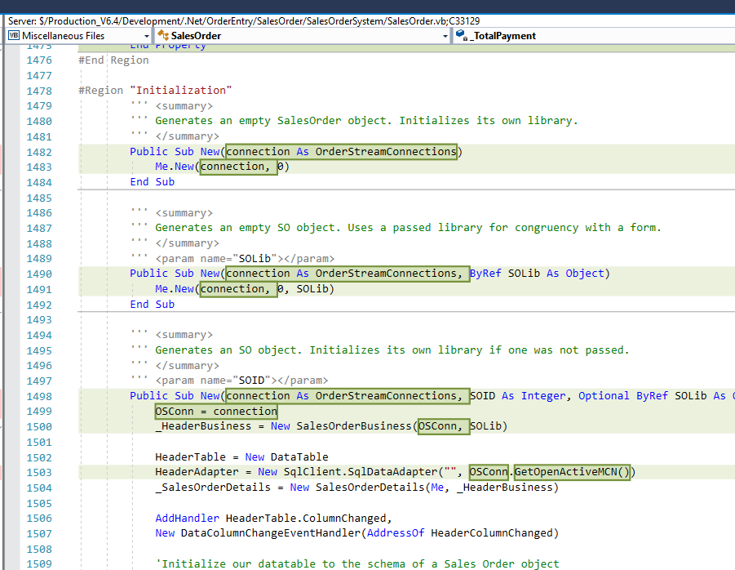
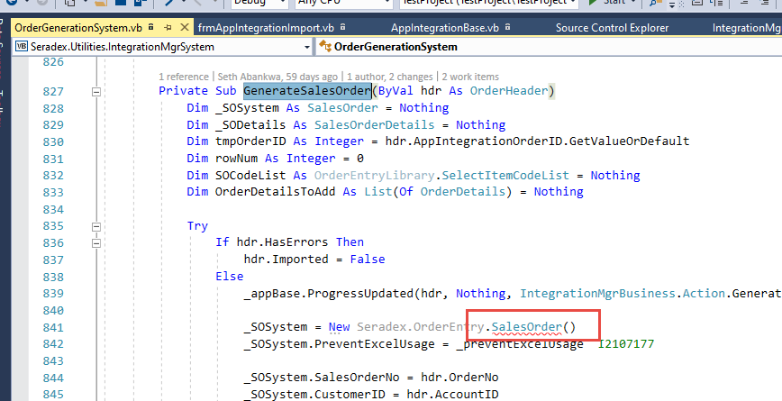

Preventative Action/Safety

Design/Architecture (Duplication, appropriate project, namespaces, maintainability)
- Not sure if you considered this, so I’ll list it here to be safe. Since we’re changing the SO form to load its connection via the runtime engine, when loading new document data into the form on load via temp tables, if the temp tables are not global temp tables(ie. ##), then this won’t work. The only place that I can think that does this is Service Order, and from what I can see it does use global temp tables so that should be fine.
Have you checked if there’s anything else that calls this method? Even if there is I think it would have to use global temps as it would probably not work with the current connection handling, anyway. But still worth it to be safe.

Data Model (Naming, good design, needs index?)

Performance (Minimize DB hits, excessive loops, queries, scalable)

UI (Alignment, naming, standardization, tab order)

Error Handling (Behind events, appropriate parameter checking)

Cleanup (Dispose code, remove handlers, large data objects)

Readability (Well-named variables, methods, clear algorithm, is it understandable)
- I see how the command Connection setting flows between the methods, but I think this might be unclear for future developers, as it splits up the connection handling between two different methods.
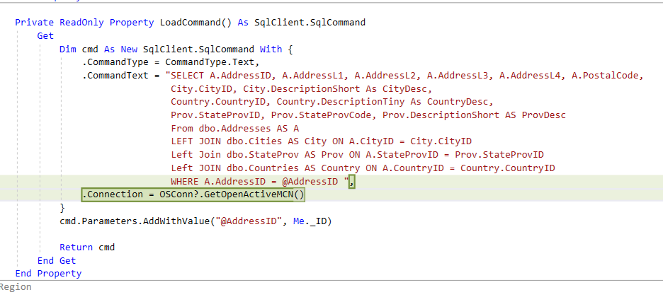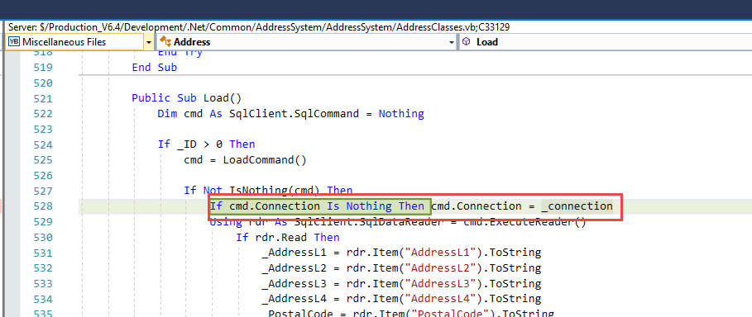
I think this would be clearer to future persons if there was an internal/private SqlConnection property that holds the logic that checks which “connection mode” the object is in, and just returns the correct value, either OSConn.GetOpenActiveM() or _connection.
There are similar changes made further down in the file in the AddressAccount class.

Comments (Useful, explains why rather than how)

Message Boxes (Grammar, spelling, captions, appropriate icons)

Ticket Management (Release Branch?, Testing Notes)

Extras
- Nit: Not sure if there was an explicit reason for using ByRef, just for consistency or if it was just a copy-paste, but I avoid the use of it unless absolutely necessary. C# and ByRef’s can be very annoying as I’m sure you’ve come across. I don’t think it really adds any value, either, except in rare cases. It looked like there were a couple uses of it in this file, but I’ve only shown one.
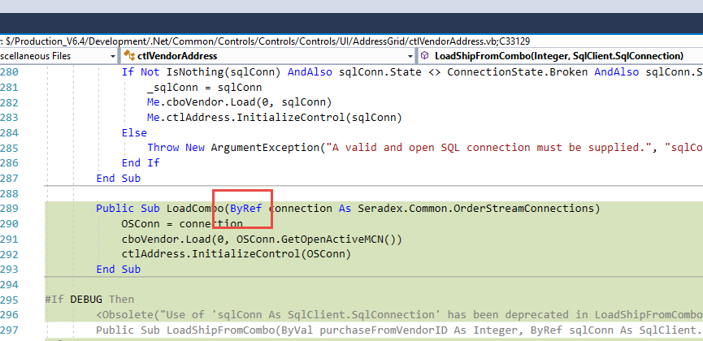

- Neat: Cool use of the DEBUG construct.
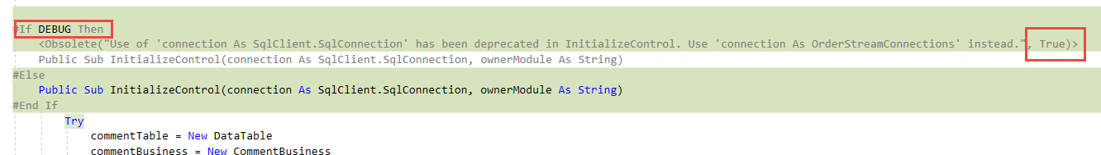

- Since we are enforcing errors on build for a lot of these files, other projects are likely going to be updated because of this(since people will want to run in Debug they’ll probably just fix and might check in). We are then relying on those tickets to handle any issues for those projects/files.
I wonder if we should just create an internal ticket to hold all non-SO related file changes for these changes. It looks like Financials uses the Address class, as an example.
Perhaps this is a question for Bryan, or maybe also get Dell’s opinion.

